CaseManagement_TestForCaseEscalation_Instance29_15-Jun-2018_07-37-01_AM_GetTextFromElement.png

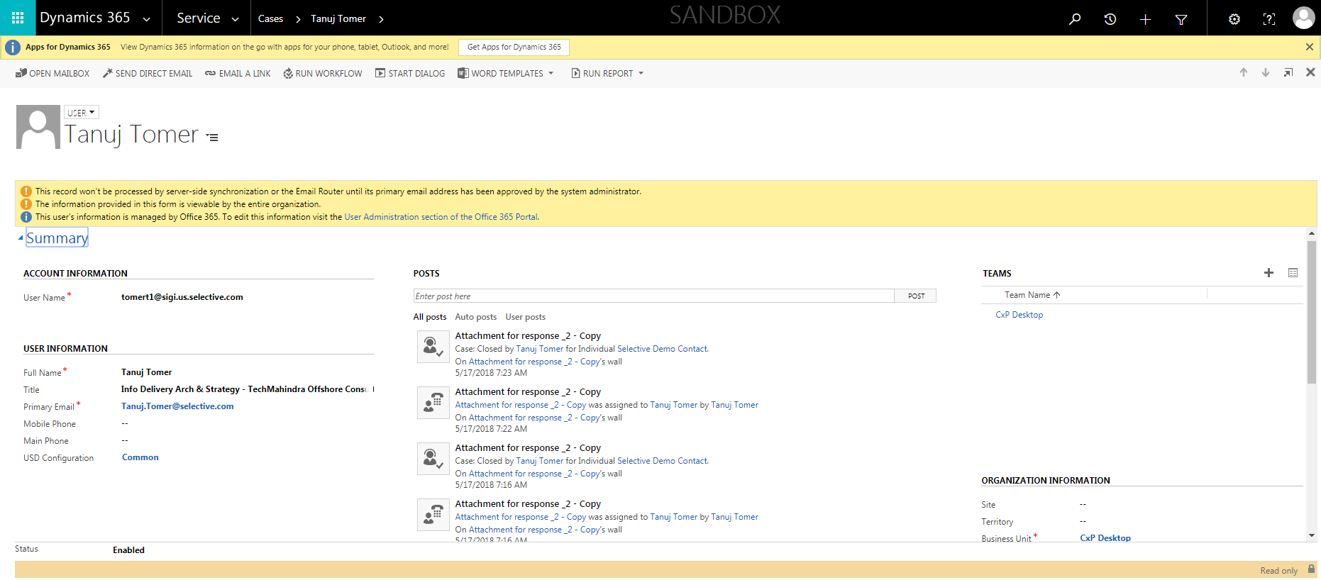

CaseManagement_TestForCaseEscalation_Instance29_15-Jun-2018_07-35-09_AM_ValidatingCaseEscalatedChanges.png

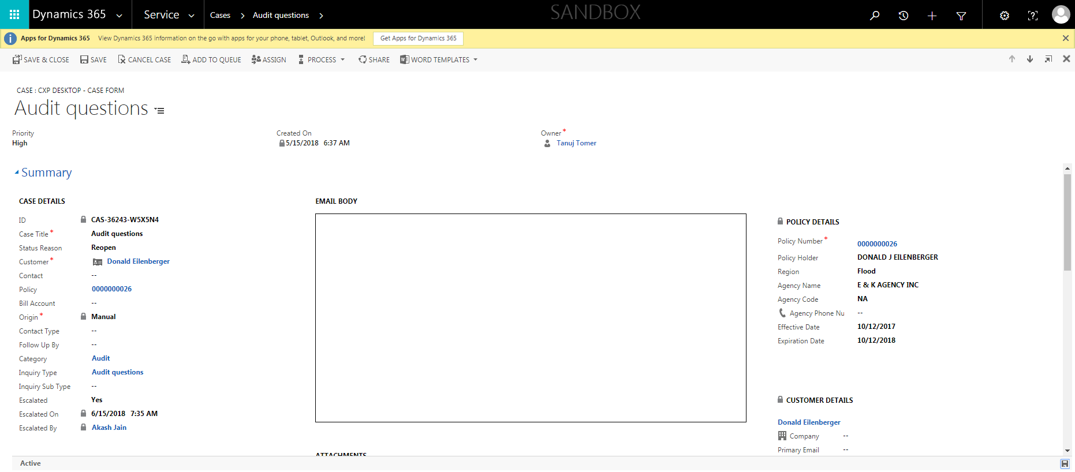

CaseManagement_TestForCaseEscalation_Instance29_15-Jun-2018_07-31-59_AM_MouseClickActiononStaleElement.png



CaseManagement_TestForCaseEscalation_Instance29_15-Jun-2018_07-35-03_AM_GetTextFromElement.png

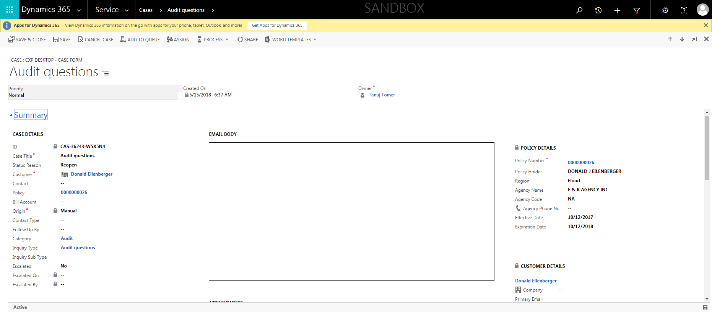

CaseManagement_TestForCaseEscalation_Instance29_15-Jun-2018_07-35-02_AM_ValidatingpresenceofReadonlyEscalatedByField.png



CaseManagement_TestForCaseEscalation_Instance29_15-Jun-2018_07-36-07_AM_MouseClickActiononStaleElement.png

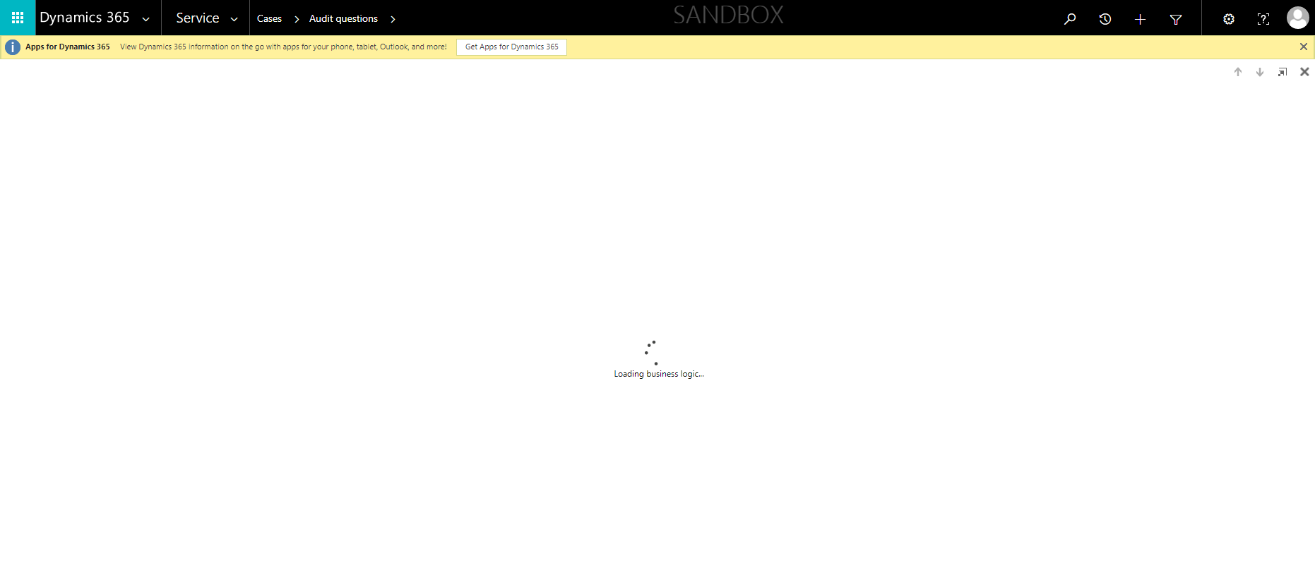

CaseManagement_TestForCaseEscalation_Instance29_15-Jun-2018_07-32-02_AM_EnterTextAction.png



CaseManagement_TestForCaseEscalation_Instance29_15-Jun-2018_07-35-10_AM_ValidatingCaseOwnerChangesafterEscalatingCase.png



CaseManagement_TestForCaseEscalation_Instance29_15-Jun-2018_07-32-31_AM_SingleSignOn.png

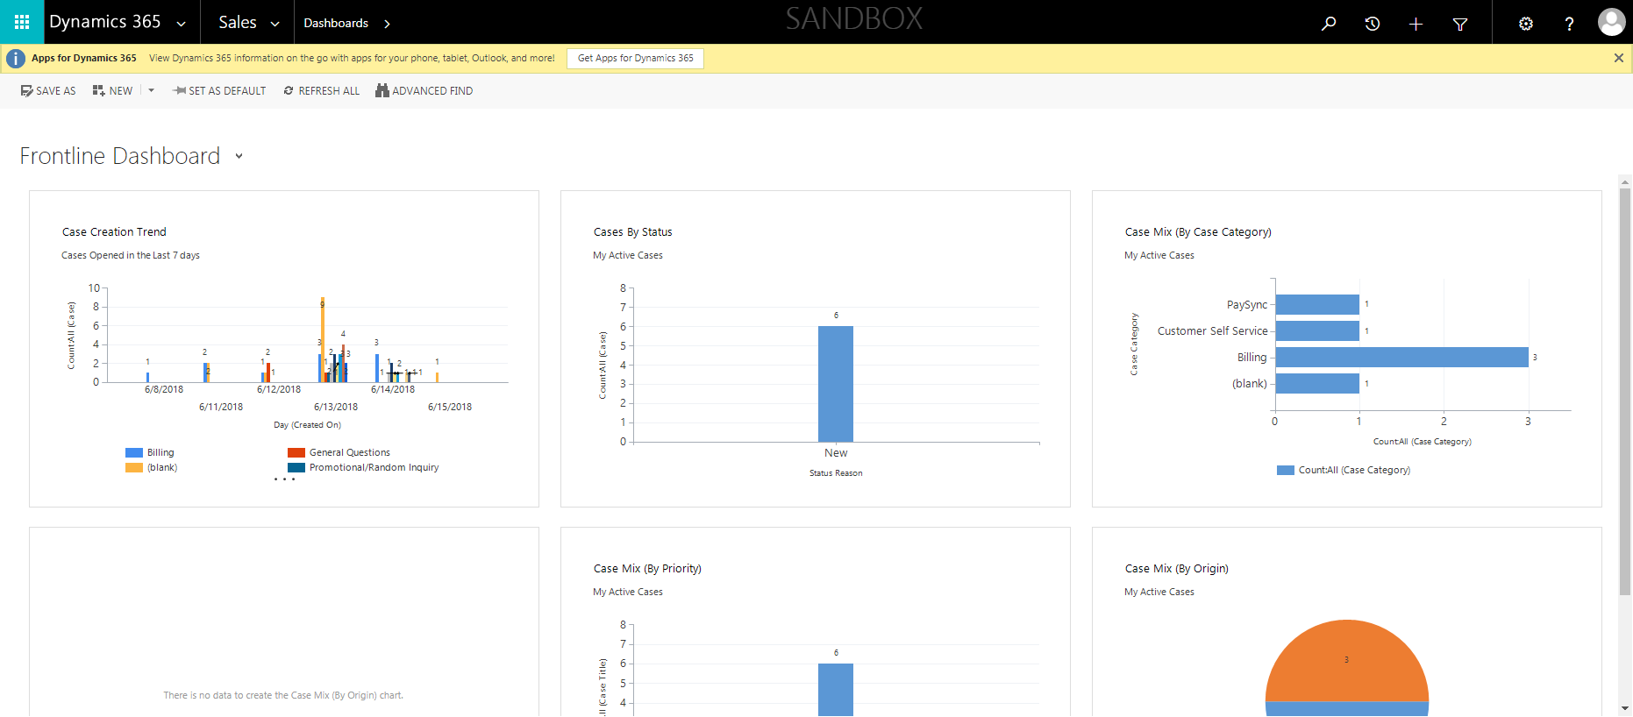

CaseManagement_TestForCaseEscalation_Instance29_15-Jun-2018_07-34-03_AM_ValidatingCaseentitynavigation.png

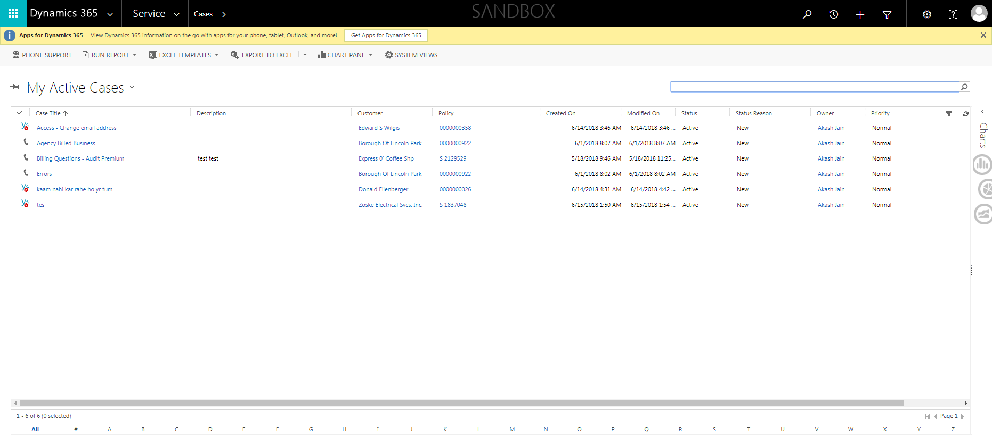

CaseManagement_TestForCaseEscalation_Instance29_15-Jun-2018_07-35-04_AM_ValidatingpresenceofEscalatedByField.png

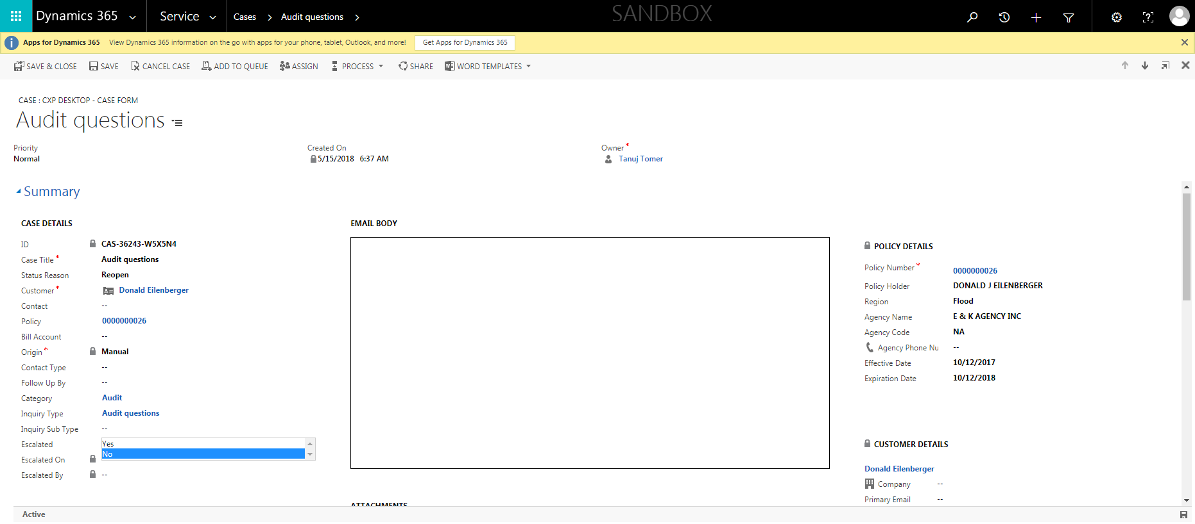

CaseManagement_TestForCaseEscalation_Instance29_15-Jun-2018_07-32-03_AM_MouseClickActiononStaleElement.png



CaseManagement_TestForCaseEscalation_Instance29_15-Jun-2018_07-37-02_AM_ValidatingManagerField.png



CaseManagement_TestForCaseEscalation_Instance29_15-Jun-2018_07-36-05_AM_ValidatingDeEsclationofcasebyFLEuser.png

